**Chapter 9 Practice questions**: Read chapter 9 carefully and see how well you can answer the following questions. Then check your answers on the following page.

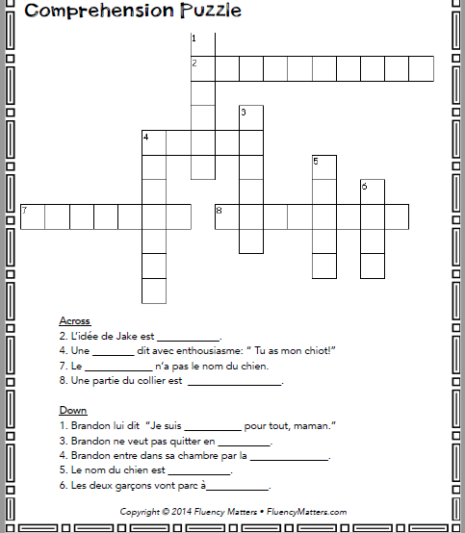

Answer sheet—

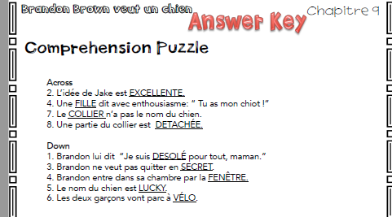

More Practice con’t below !!!!!!!!!!!!!!!

Try to answer the following questions based on what you just read-then check your answers on the following page.

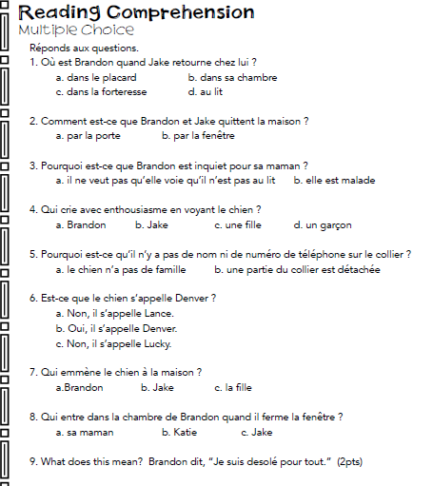

Answer sheet—HOW DID YOU DO??

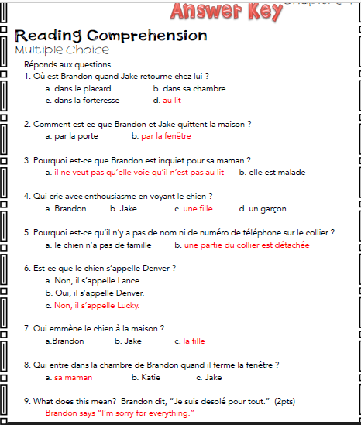

**Once you have completed ALL your practice—complete the following Quiz. You must put your answers on the ANSWER SHEET in TEAMS and submit it to me for a grade.**

